SYDNEY SECONDARY COLLEGE BLACKWATTLE BAY CAMPUS
YEAR 12 HALF YEARLY EXAM – 2008
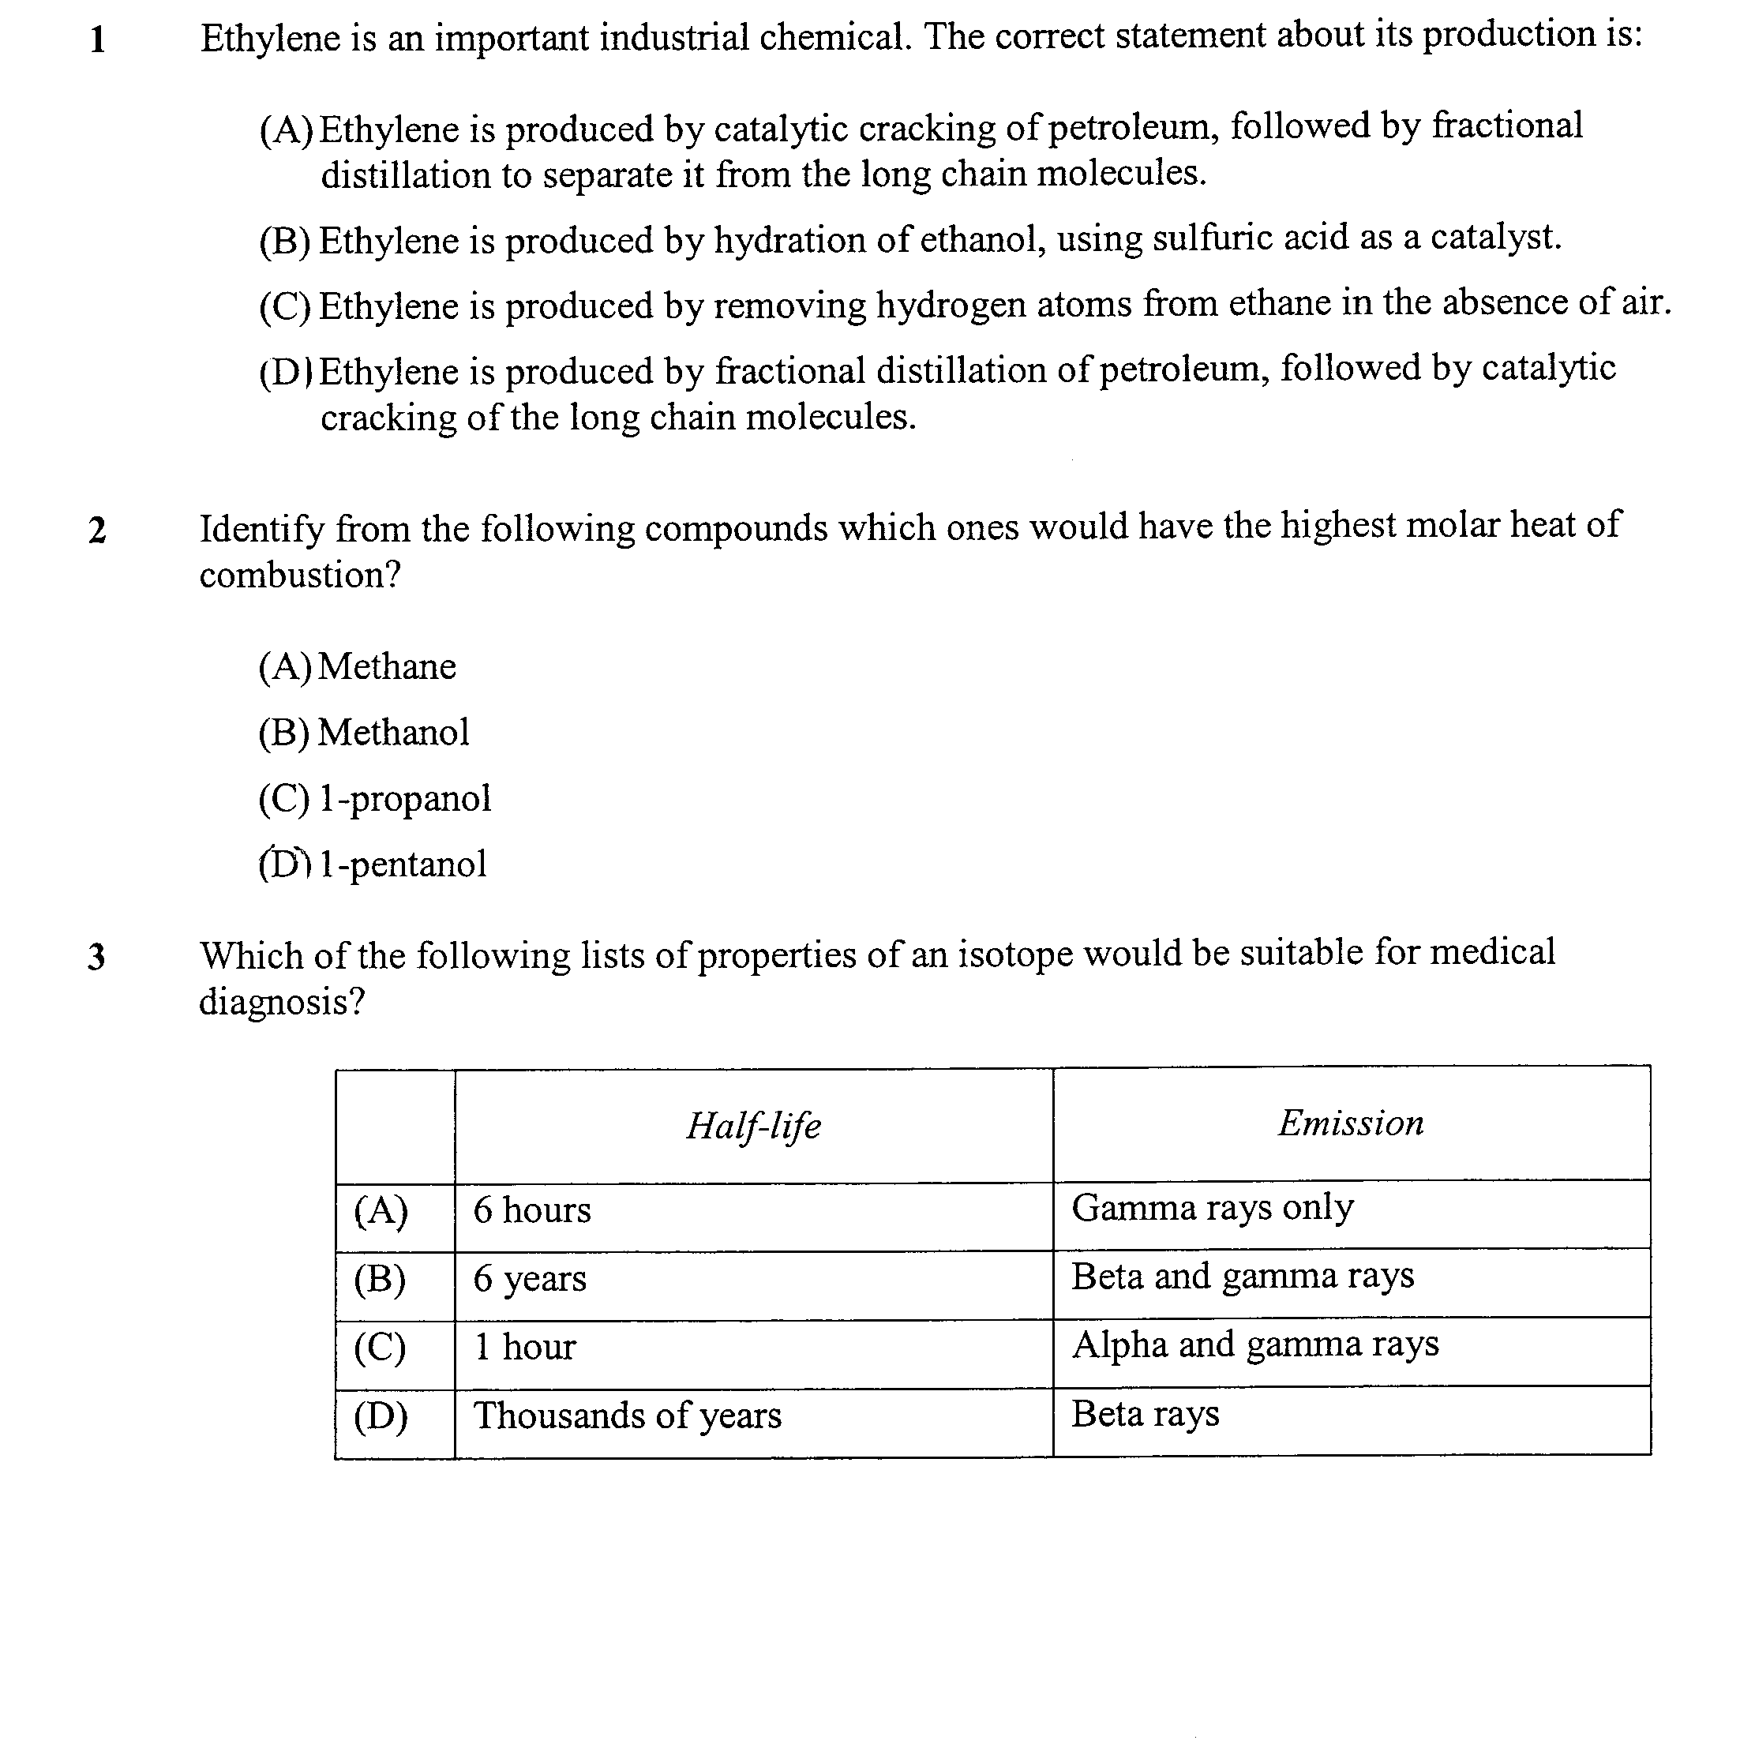

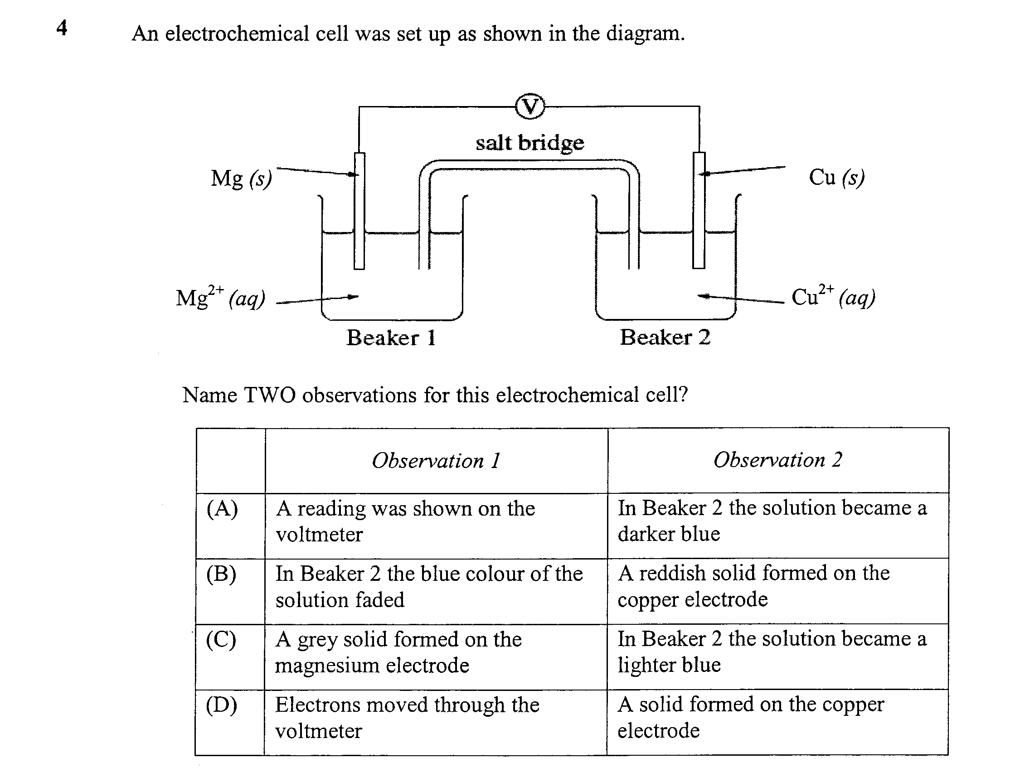

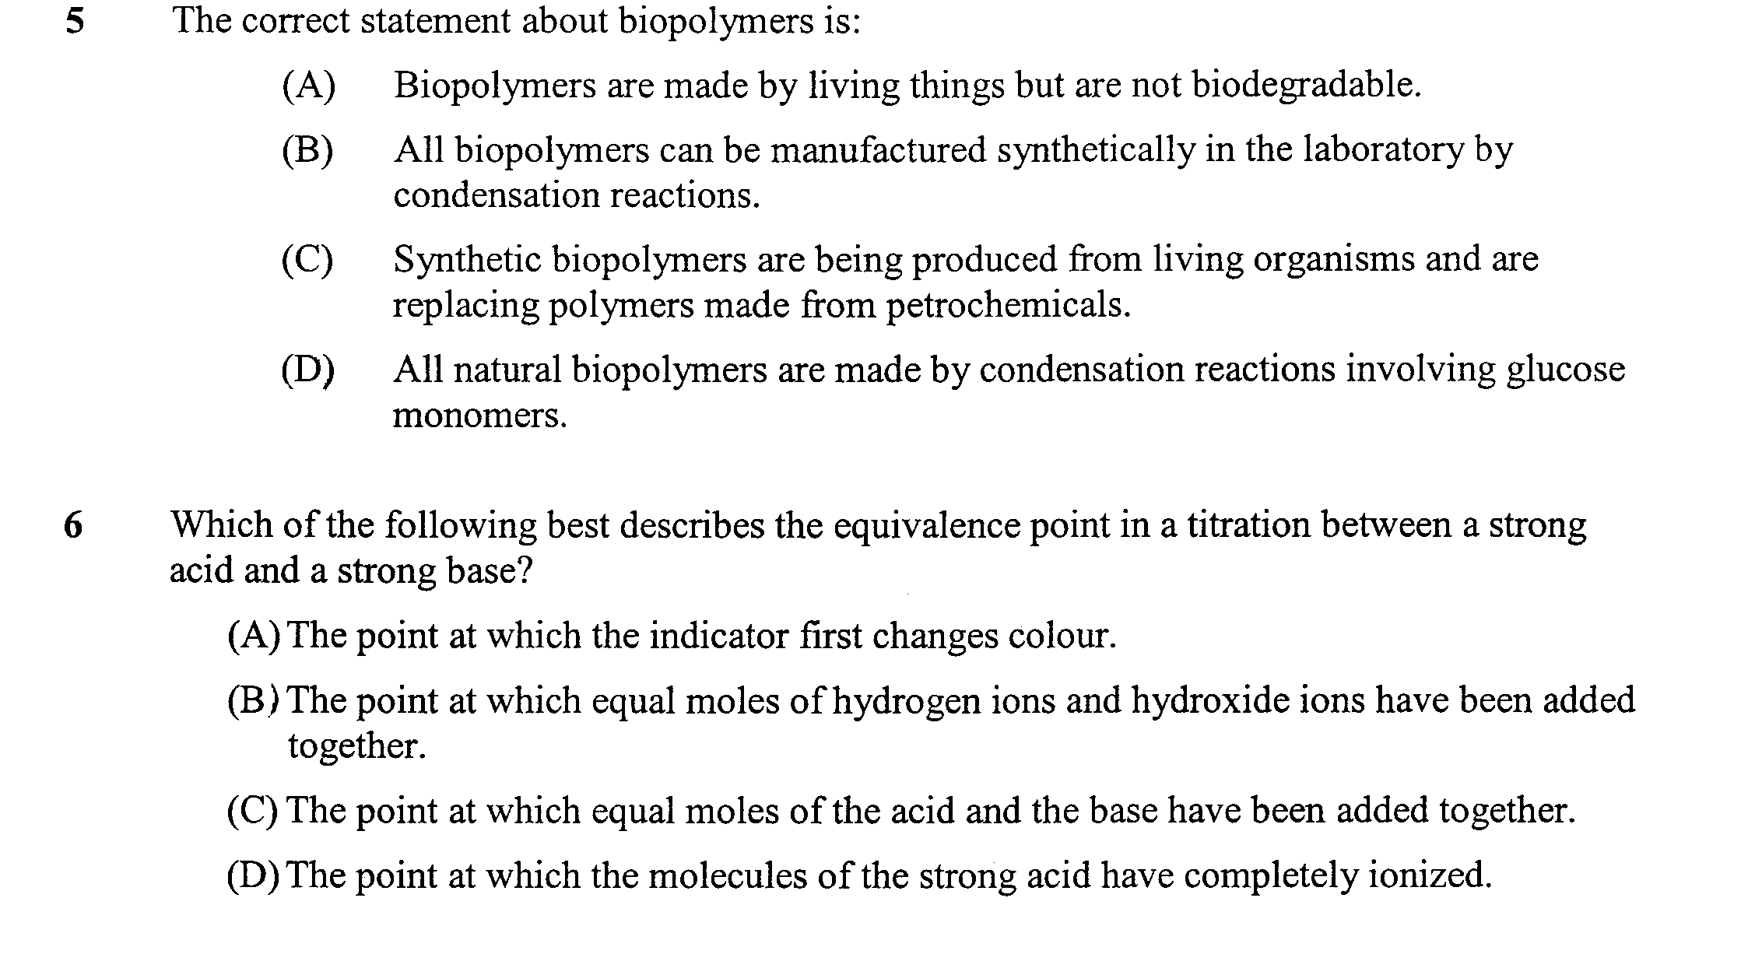

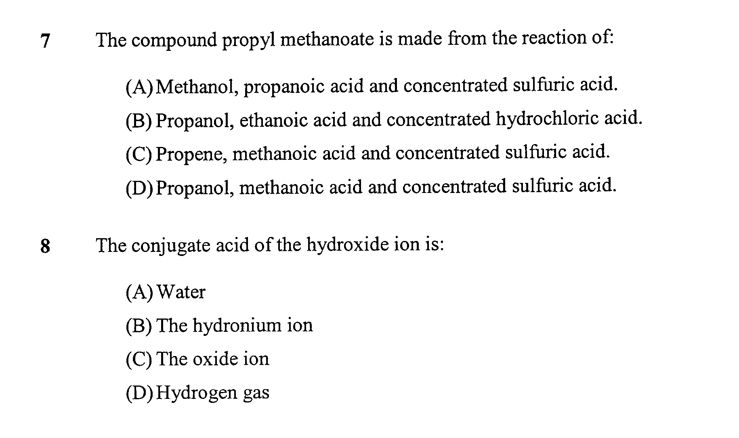

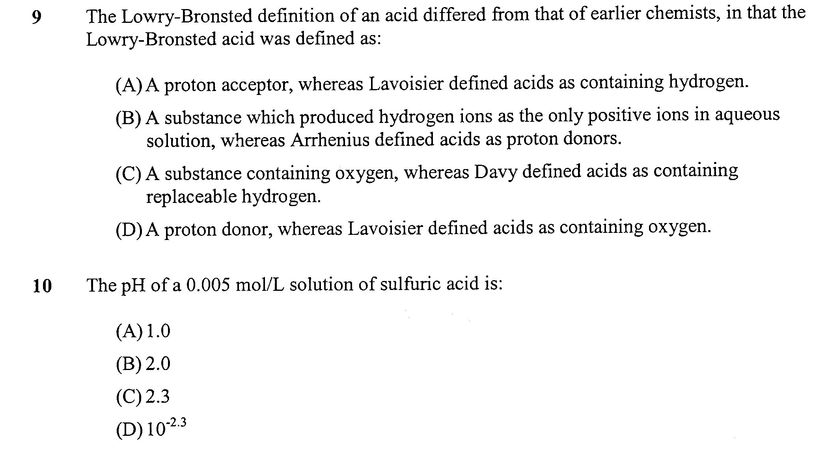

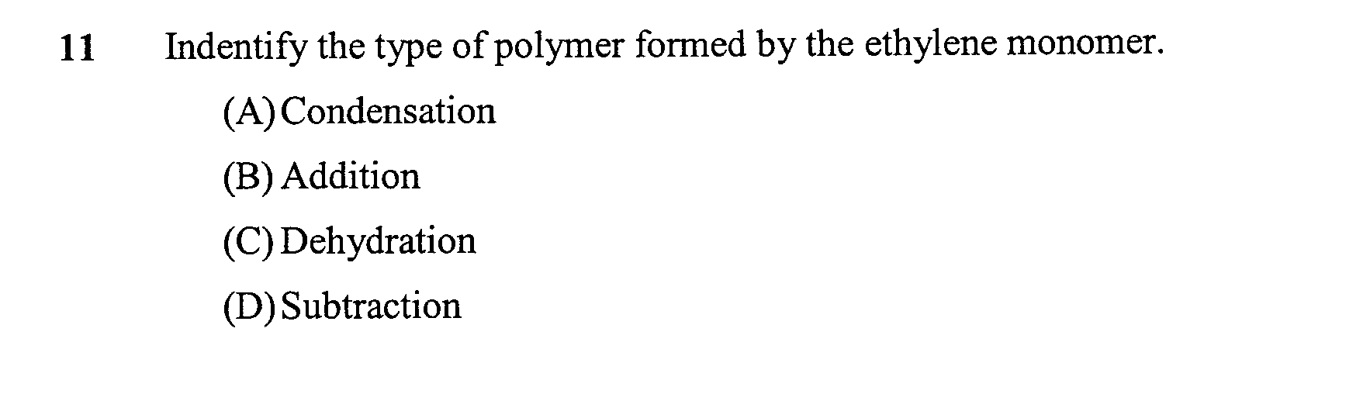

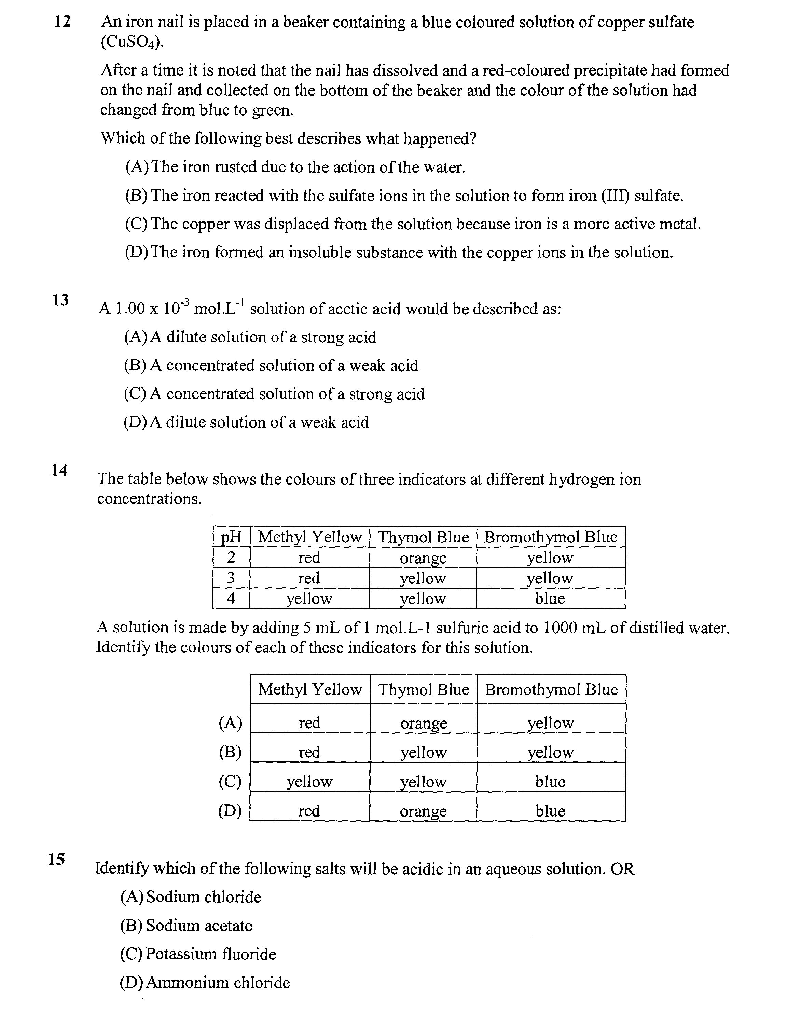

Question 16 (4 marks)

Cellulose is a polymer and is the structural carbohydrate found in all plant cells

- Outline the structure and formation of the cellulose polymer chain

………………………………………………………………………………………………………………..

………………………………………………………………………………………………………………..

b. Neighbouring polymer chains of cellulose are closely linked by strong intermolecular forces. Explain the
reasons for these strong intermolecular forces

………………………………………………………………………………………………………………..

………………………………………………………………………………………………………………..

Question 17 (6 marks)

Over the past decades, ethylene has been an important industrial chemical. However, the role of ethylene may change in the future.

Discuss the role of ethylene as a source of materials for society in past decades and assess its role in the future

………………………………………………………………………………………………………………..

………………………………………………………………………………………………………………..

………………………………………………………………………………………………………………..

………………………………………………………………………………………………………………..

………………………………………………………………………………………………………………..

………………………………………………………………………………………………………………..

………………………………………………………………………………………………………………..

………………………………………………………………………………………………………………..

………………………………………………………………………………………………………………..

………………………………………………………………………………………………………………..

………………………………………………………………………………………………………………..

………………………………………………………………………………………………………………..

………………………………………………………………………………………………………………..

………………………………………………………………………………………………………………..

………………………………………………………………………………………………………………..

………………………………………………………………………………………………………………..

………………………………………………………………………………………………………………..

………………………………………………………………………………………………………………..

Question 18 (5 marks)
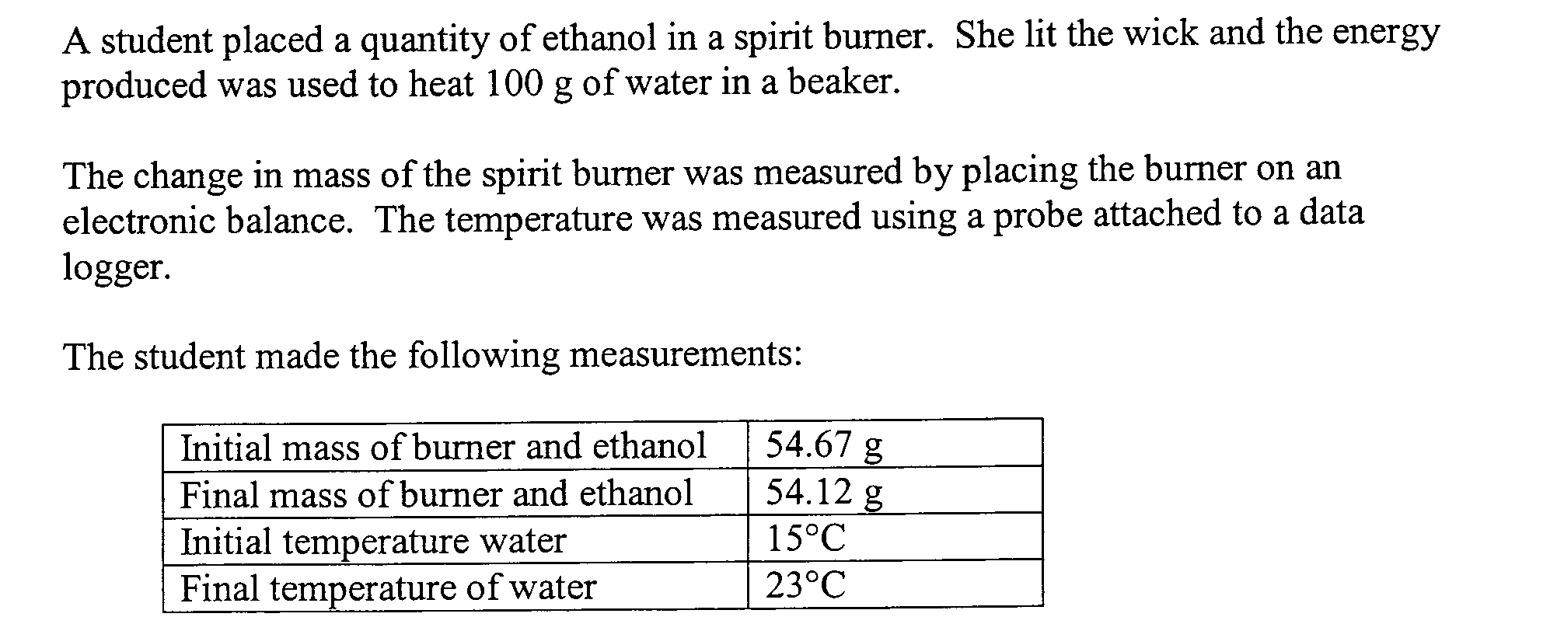

(a). Calculate the heat of combustion of ethanol, in kJ/g and kJ/mol

………………………………………………………………………………………………………………..

………………………………………………………………………………………………………………..

………………………………………………………………………………………………………………..

………………………………………………………………………………………………………………..

………………………………………………………………………………………………………………..

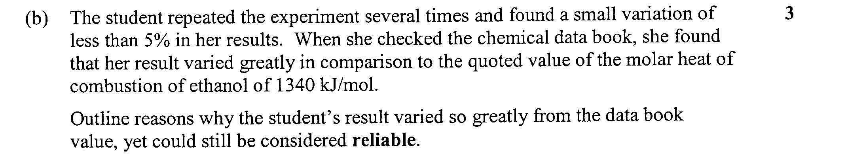

………………………………………………………………………………………………………………..

………………………………………………………………………………………………………………..

………………………………………………………………………………………………………………..

………………………………………………………………………………………………………………..

………………………………………………………………………………………………………………..

………………………………………………………………………………………………………………..

………………………………………………………………………………………………………………..

………………………………………………………………………………………………………………..

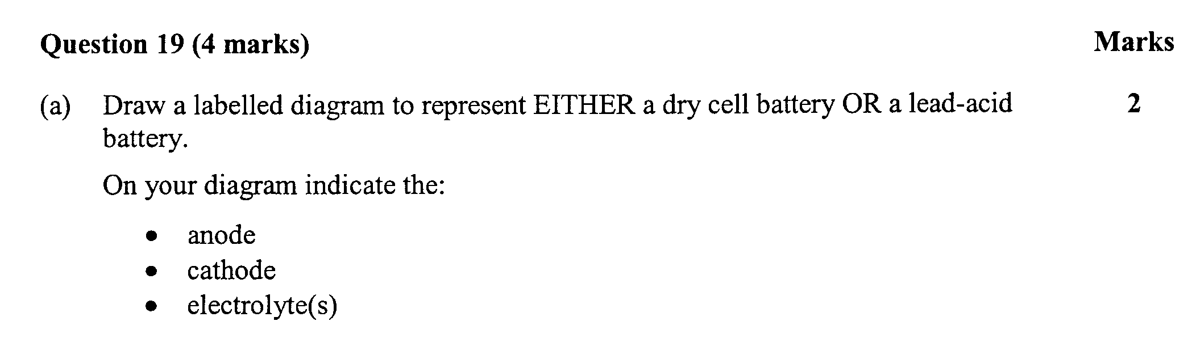

(b) Write the half equations for BOTH half-cell reactions 2

………………………………………………………………………………………………………………..

………………………………………………………………………………………………………………..
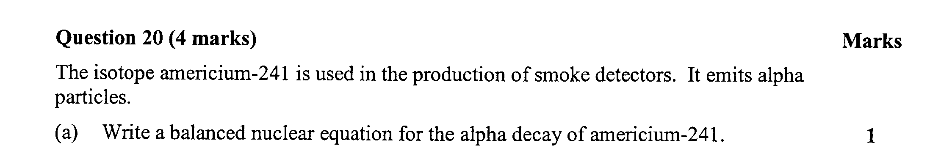

………………………………………………………………………………………………………………..

………………………………………………………………………………………………………………..
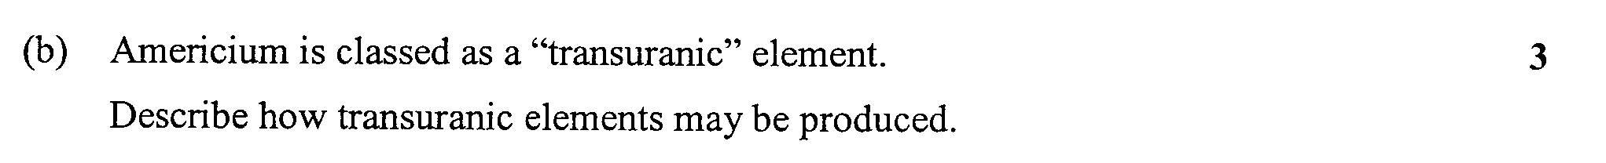

………………………………………………………………………………………………………………..

………………………………………………………………………………………………………………..

………………………………………………………………………………………………………………..

………………………………………………………………………………………………………………..
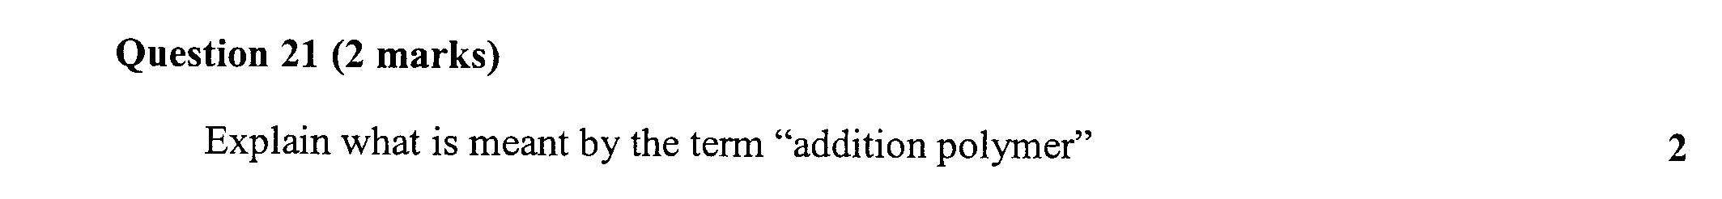

………………………………………………………………………………………………………………..

………………………………………………………………………………………………………………..

………………………………………………………………………………………………………………..

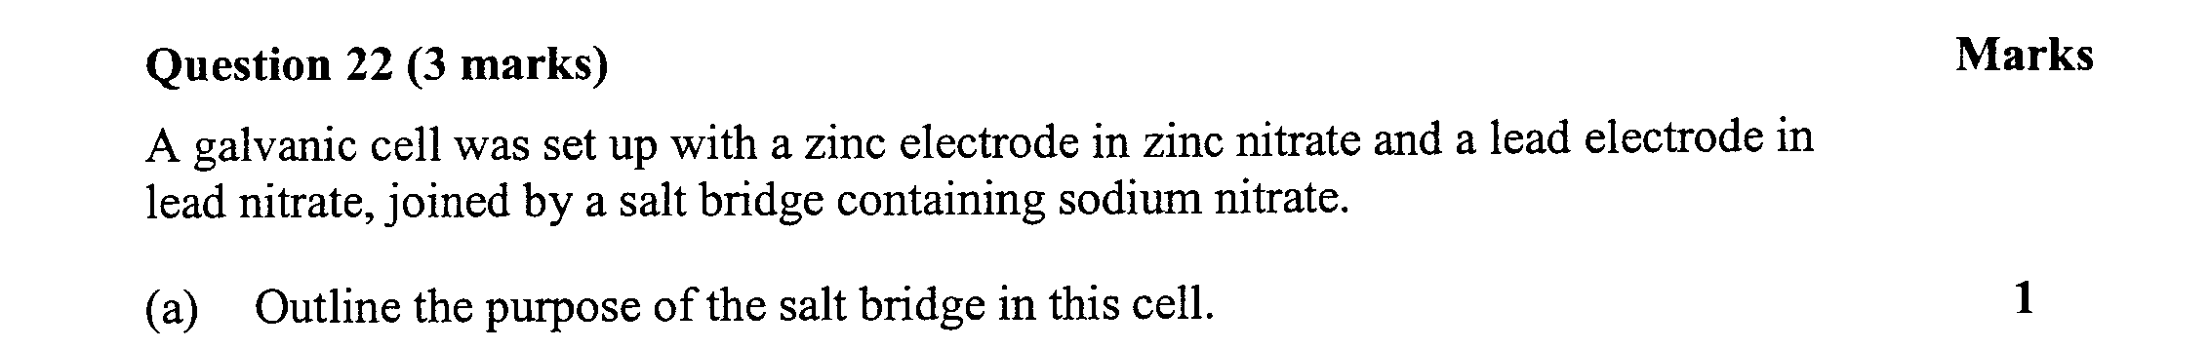

………………………………………………………………………………………………………………..

………………………………………………………………………………………………………………..
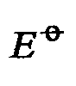
(b) Calculate the potential of this cell 2

………………………………………………………………………………………………………………..

………………………………………………………………………………………………………………..

………………………………………………………………………………………………………………..

………………………………………………………………………………………………………………..

………………………………………………………………………………………………………………..
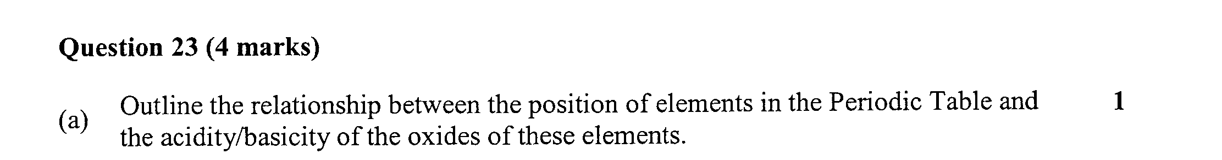

………………………………………………………………………………………………………………..

………………………………………………………………………………………………………………..
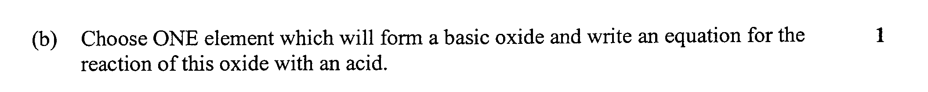

………………………………………………………………………………………………………………..

………………………………………………………………………………………………………………..
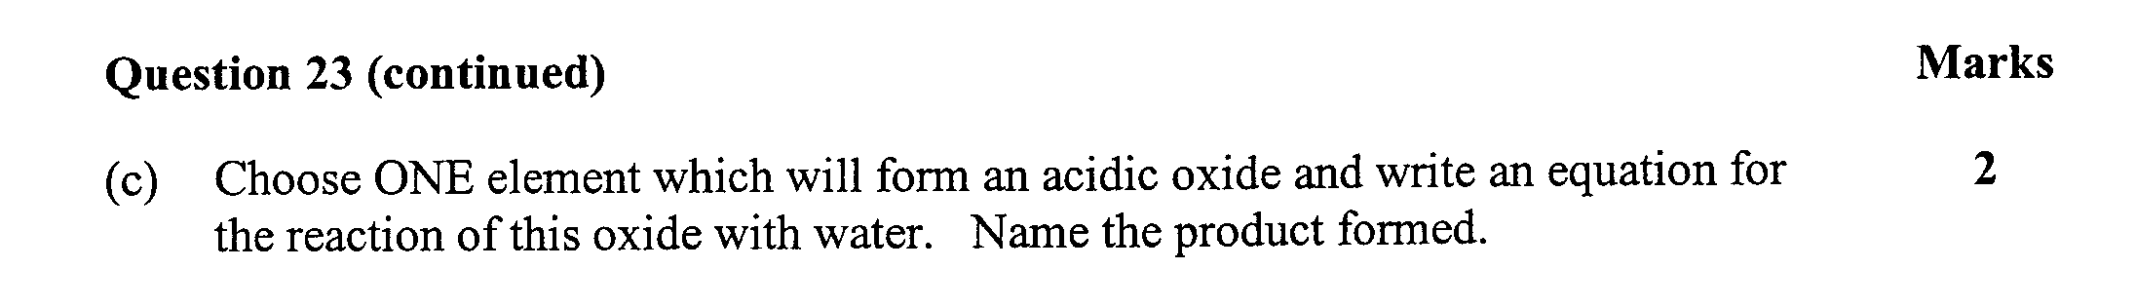

………………………………………………………………………………………………………………..

………………………………………………………………………………………………………………..
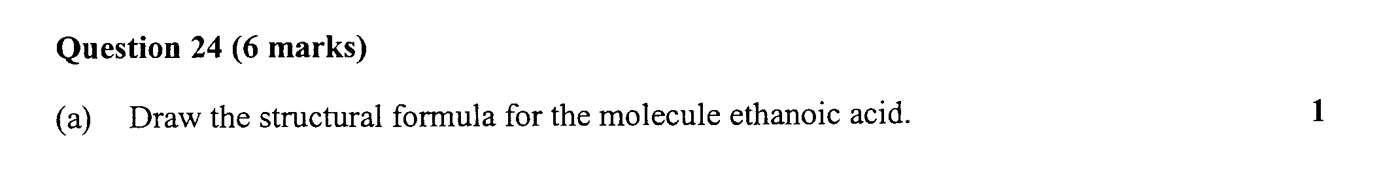

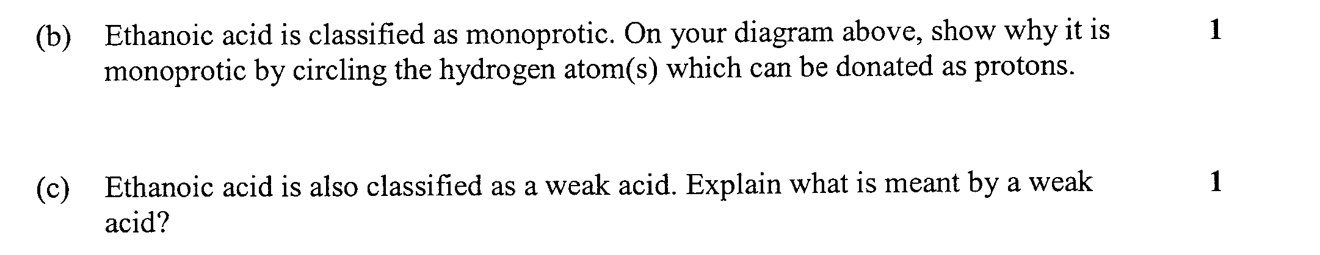

………………………………………………………………………………………………………………..

………………………………………………………………………………………………………………..

………………………………………………………………………………………………………………..

Question 24 (continued) 3 marks

- A student was given a beaker of ethanoic acid solution and a beaker of hydrochloric acid solution. She tested each with a pH meter and found they both had the same pH

List the particles which would be present in EACH of the beakers and hence explain how it is possible for the TWO solutions to have the same pH

………………………………………………………………………………………………………………..

………………………………………………………………………………………………………………..

………………………………………………………………………………………………………………..

………………………………………………………………………………………………………………..

………………………………………………………………………………………………………………..

………………………………………………………………………………………………………………..

Question 25 (4 marks)

Gaseous sulfur dioxide (SO₂) may be released as a by-product of the combustion of certain types of coal. This gas readily dissolves in water in the atmosphere leading to a lowering of the pH of the water

(a) Write a balanced equation for the reaction of sulfur dioxide with water 1

………………………………………………………………………………………………………………..

(b) What pH must rain water reach in order to be described as “acid rain”? 1

………………………………………………………………………………………………………………..
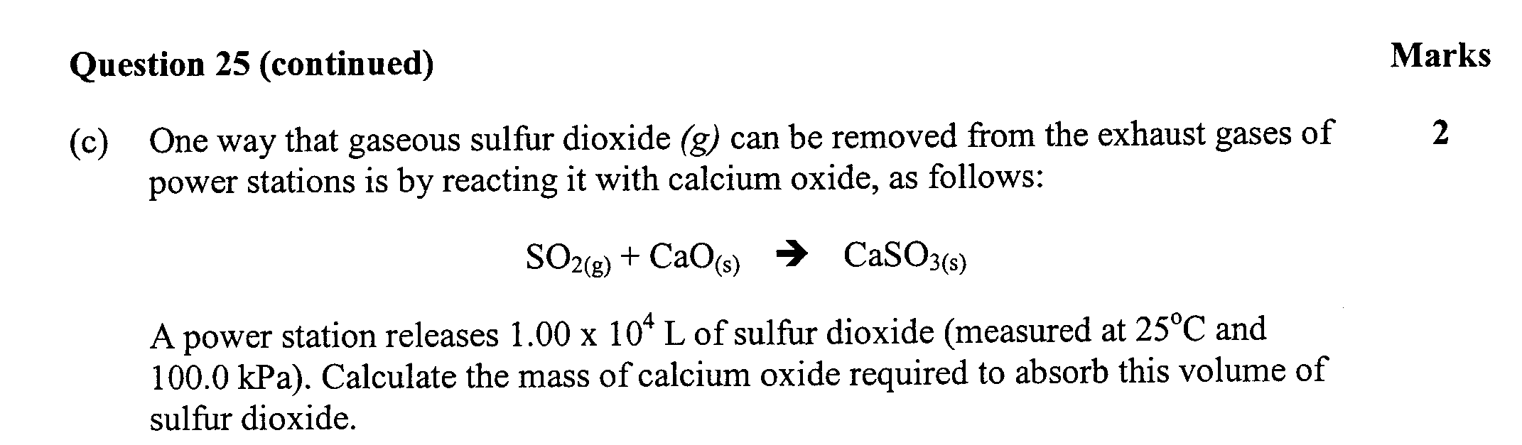

………………………………………………………………………………………………………………..

………………………………………………………………………………………………………………..

………………………………………………………………………………………………………………..

………………………………………………………………………………………………………………..

………………………………………………………………………………………………………………..
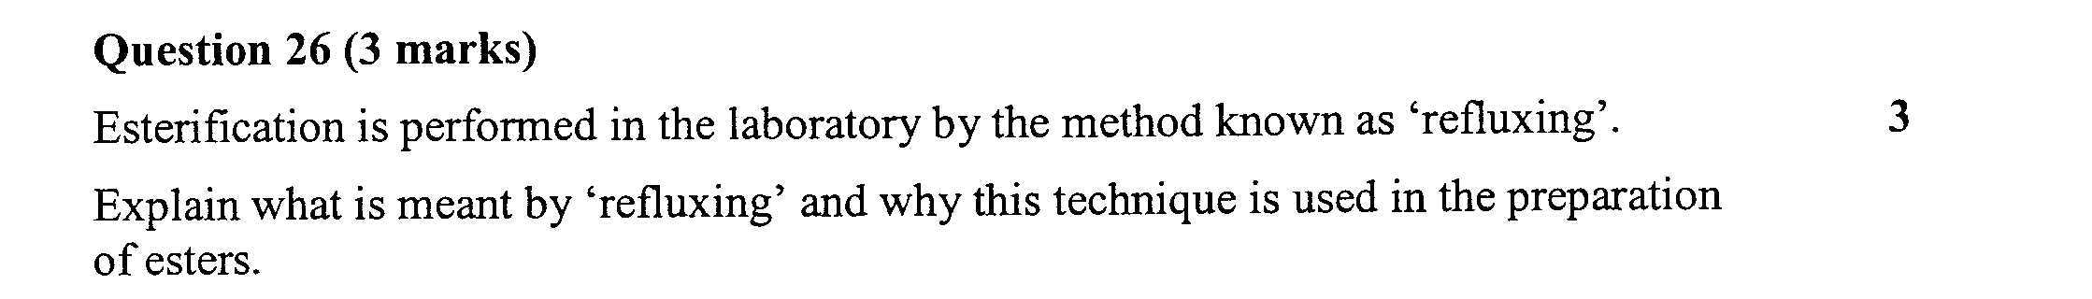

………………………………………………………………………………………………………………..

………………………………………………………………………………………………………………..

………………………………………………………………………………………………………………..

………………………………………………………………………………………………………………..

………………………………………………………………………………………………………………..

………………………………………………………………………………………………………………..

………………………………………………………………………………………………………………..
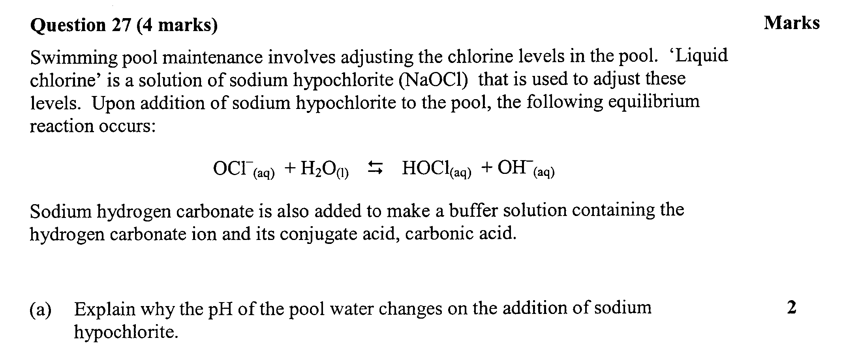

………………………………………………………………………………………………………………..

………………………………………………………………………………………………………………..

………………………………………………………………………………………………………………..

………………………………………………………………………………………………………………..

………………………………………………………………………………………………………………..

………………………………………………………………………………………………………………..

………………………………………………………………………………………………………………..

Question 28 (1 mark)

Define Le Chaterlier’s Principle

………………………………………………………………………………………………………………..

………………………………………………………………………………………………………………..

………………………………………………………………………………………………………………..

Question 29 (2 marks)

(a) State the name of one acid you have studied that is used as a food additive 1

………………………………………………………………………………………………………………..

(b) For the acid you named in (a) identify why it is used as a food additive 1

………………………………………………………………………………………………………………..

………………………………………………………………………………………………………………..

………………………………………………………………………………………………………………..

Question 30 (3 marks)

Two 100.0 mL volumetric flasks contain 0.010 mol/L solutions of sulfuric and acetic acids.

Describe, with the use of balance chemical equations, the difference between the two solutions in terms of the equilibrium between the intact acid molecules and the ions formed in each solution

………………………………………………………………………………………………………………..

………………………………………………………………………………………………………………..

………………………………………………………………………………………………………………..

………………………………………………………………………………………………………………..

………………………………………………………………………………………………………………..

………………………………………………………………………………………………………………..

………………………………………………………………………………………………………………..

………………………………………………………………………………………………………………..

………………………………………………………………………………………………………………..

………………………………………………………………………………………………………………..

………………………………………………………………………………………………………………..

